**Get the data**

Excel / csv / html / json / images / text /

Types of data measurement scale

1. Nominal (qualitative data)/ categorical variables

Martial status (Married/unmarried/divorced)

Industry type(manufacturing/ it/pharma)

1. Ordinal Scale

Feedback (Likert Scale [1-5])

1. Interval Scale

Intelligence (IQ), temperature

1. Ratio scale

Wherever ratio can be calculated

Ram’s salary is 80k

Shyam’s salary is 40k

**Store the date**

List/ dataframe / dictionary / numpy array



**Access the data**

From list

From dataframes

From Dictionary

**Enjoy/break your head with data**



1 Numerical and categorical values

Ref basic python

<https://www.w3schools.com/python/python_comments.asp>

Week 2

Data Visualization



Î

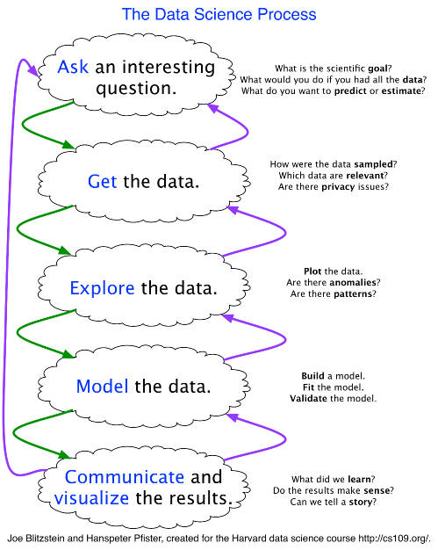





HISTOGRAM

Frequency / Probability distribution

﻿1. The shape of the distribution and to assess the probability distribution of the data.

2. Measures of central tendency such as median and mode.

3. Measures of variability such as spread.

4. Measure of shape such as skewness.



Sturges Formula



BAR CHART

Frequency chart for **qualitative/ categorical** data

PIE CHART

Again categorical / only when number of categories are small

SCATTER PLOT

* Strength of relationship
* Get outliers

BOX PLOT

* For numerical data
* Get spread and outlier if any
* Lower quartile,median, upper quartile
* Min-max
* IQR = length of box
* Outlier = Q1 – 1.5 IQR / Q3 + 1.5IQR

﻿

U Dinesh Kumar. Business Analytics: The Science of Data-Driven Decision Making